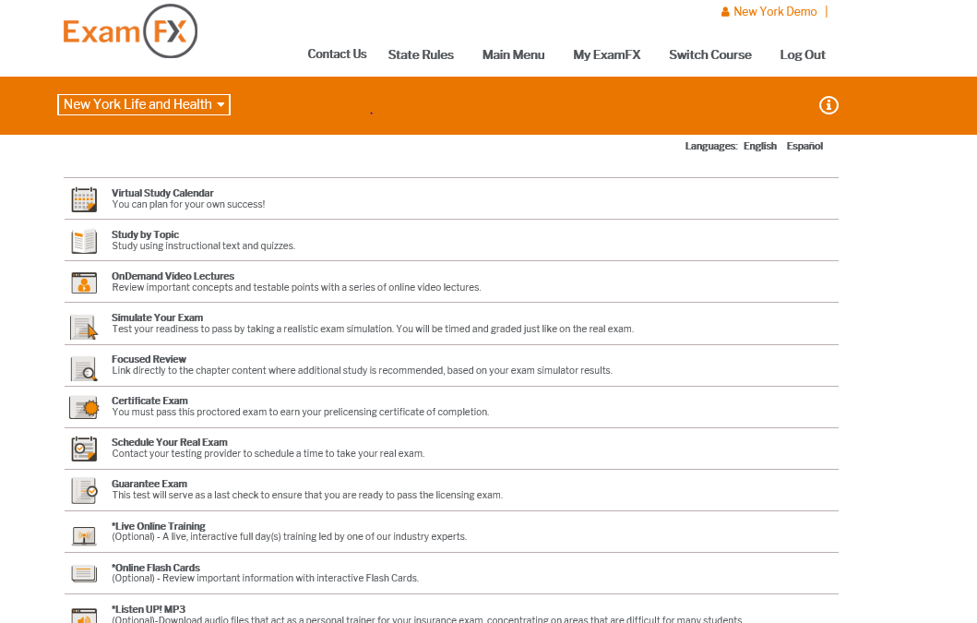

When you log in to the course, go to the Virtual Study Calendar. From here, you will see the next screenshot. To customize the calendar, go to calendar preferences (when the course is new, there will be something that says, customize, or calendar preferences, to start the custom calendar process)
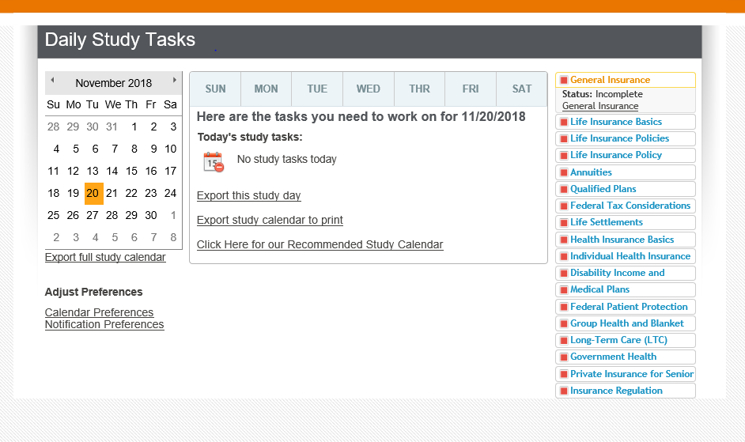
The next screen will have Calendar Preferences. You can select the day you are going to start studying and the day you want to be test ready by. This is entirely up to you and the recruit. They can tell you what days they are available to study and exclude any dates that they cannot study on. Once all this information has been entered, click save.

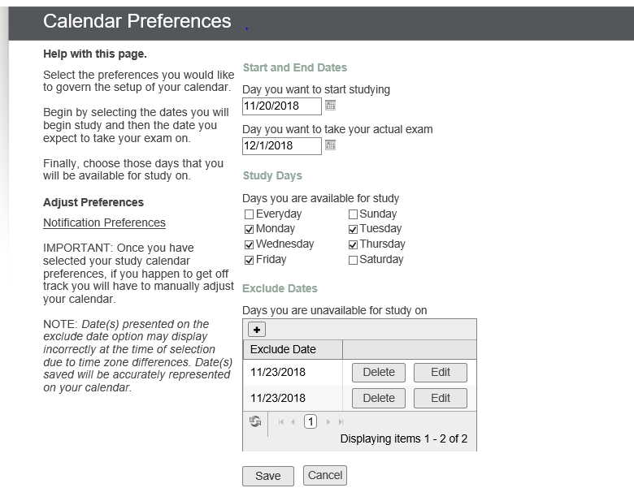
Now the calendar provides you with everything you need to do each day you entered that you could study to be test ready by the agreed upon date. In the case of this calendar, I would be test ready by December 1st, 2018, if I followed each day’s tasks.
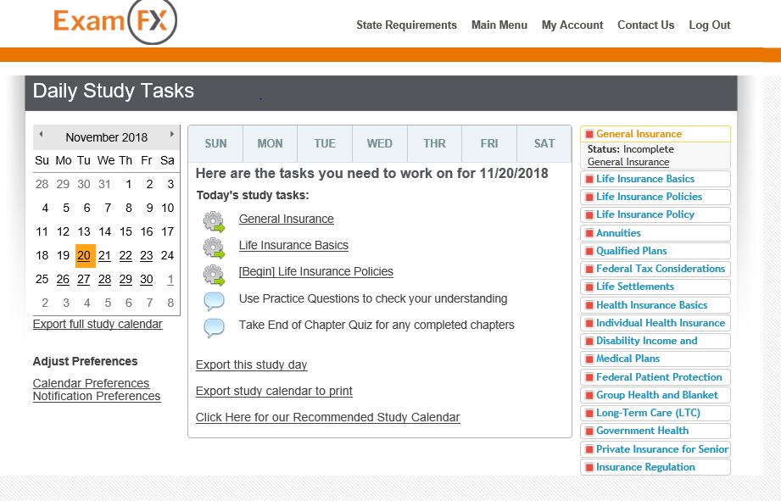

You can also set up Notification preferences.
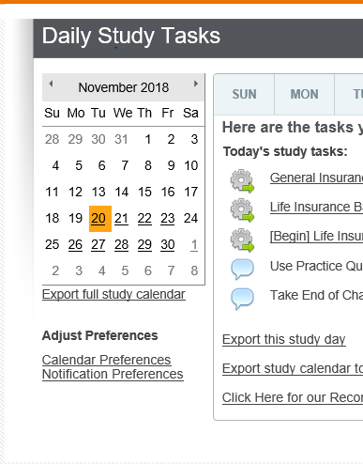
Once you click on notification preferences, it takes you to the below screen. You can request notifications be sent to the recruit, and the time (daily, weekly, or both) and the email. Click save and notifications will go out as well to the recruit according to the calendar. If they miss a day of studying, the materials from the day they missed will be moved to the next day with everything else they already had as well.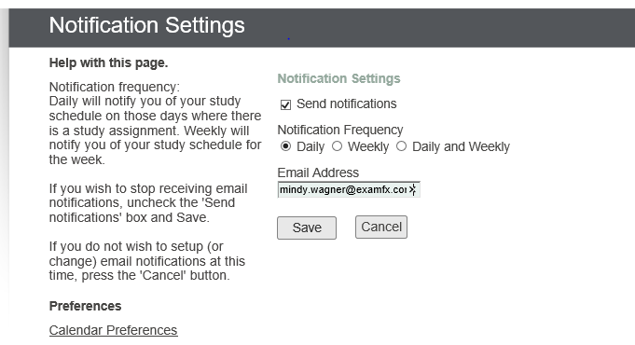

You can also export this study calendar to print and have one for yourself for their file, and they can have a printed copy as well. 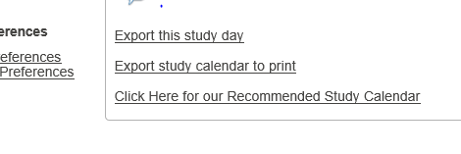
The calendar will look like the below.
